Extended Response Question

On the HHD Exam, there will be (at least) one question worth 8, 9 or 10 marks. This question may have multiple pieces of stimulus material that must be drawn upon when constructing an answer.
Some considerations for this question include:
  - Break the question down into each of its parts. In order to achieve a high score for this question, all parts of the question must be addressed. For example, consider the following question:
Selecting evidence from the sources presented and using your understanding of dietary change, draw conclusions about the impact of dietary initiatives on the health and wellbeing of Australians, and the challenges faced by organisations that are focused on bringing about dietary change in Australia.

In order to satisfy the requirements of this question, you must:
- Select evidence from the sources presented
- Use your understanding of dietary change
- Draw conclusions about the impact of dietary initiatives on the health and wellbeing of Australians
- Draw conclusion about the challenges faced by organisations that are focused on bringing about dietary change in Australia.

You can think of these requirements like a checklist. You can create your own by using strokes (forward slashes) to break the question down:
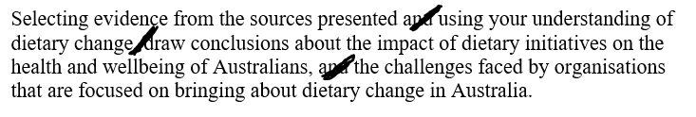
You can then place a tick next to each component when you feel you have adequately addressed it:
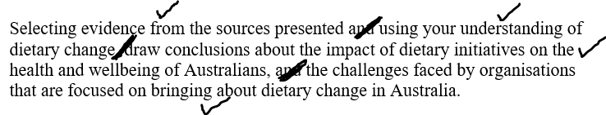
  - If multiple pieces of stimulus are provided, do all sources need to be included at some stage in the response?
  - If the question asks you to analyse, you need to examine the provided materials in detail. You will need to break it down into its parts in order to explain it. You will need to look at it from all angles. Is all the information provided positive / negative? If not, explain the information that goes against what the rest is showing.
  - If the question asks you to draw conclusions, you must include conclusions in your answer. A conclusion can be as basic as ‘Males have poorer health status than females’, but then you will probably be required to back this conclusion up with material provided and / or your own knowledge.
  - If the question is asking you to what extent you agree or disagree with a statement, think of it like a continuum. If you completely agree or disagree, then your argument will be one-sided. For many of these questions however, you will be somewhere towards the middle. If that is the case, your discussion might be 4 and 4 (four marks worth of discussion as to why you agree and 4 marks of discussion for why you disagree).
  - Think about how much time you will need to invest in these responses. Consider leaving these questions until you have completed all of the shorter questions you are confident with.
  - Be prepared to apply your knowledge. Each application question will be drawing on your knowledge of some part of the course. These questions will require you to use this knowledge in an unfamiliar scenario. If you draw a blank, DO NOT PANIC! You know the content required, so slow down and think about which parts you need to use.

Looking at an extended response question

Selecting evidence from the sources presented and using your understanding of dietary change, draw conclusions about the impact of dietary initiatives on the health and wellbeing of Australians, and the challenges faced by organisations that are focused on bringing about dietary change in Australia.

Requirements:
Draw on the information provided throughout the response.
Apply your own knowledge.
Conclusions must be drawn.
Links to health and wellbeing (dimensions) must be made.
Challenges faced by organisations working to bring about dietary change must be included.

Considerations:
Which dot points does the question relate to? It relates to a number of dot points, so plan carefully.
Leave it until the end?
Some change – Nudge project.
Obesity rates still increasing – but the rate of increase has slowed between 2011-12 and 2014-15
The guidelines are readily available, but only 24% of women and 15% of men meet guidelines for both fruit and veg.
An example of a high scoring response:
Achieving dietary change in Australia can be difficult. According to Source 1, of those who noticed the ‘nudge’ project (3/4 of customers) at Alfred Health, 77% said it influenced their meal choice. This contributed to a 26% increase in the purchase of the green ‘healthier’ meals and a 17% decrease in the ‘unhealthy’ red meals. This shows that with an easy to follow system, people will take notice of dietary initiatives. Obesity rates are fairly high in Australia increasing the risk of a range of conditions such as cardiovascular disease and arthritis. These conditions can cause pain which impacts physical health and wellbeing. People may also be stressed as a result of diet-related diseases which impacts mental health and wellbeing. According to Source 2, the rate of obesity in Australia has increased over time (from 18.7% in 1995, to 24.8% in 2007-08, 27.5% in 2011-12 and 27.9% in 2014-15), although the rate of increase has slowed in recent years, meaning that these initiatives may be having some impact on some people. This can mean that fewer people are becoming obese due to dietary initiatives like ‘nudge’ which can mean that fewer people are developing diet-related disease which improves their health and wellbeing. The Australian Guide to Healthy Eating and Australian Dietary Guidelines are readily available resources to assist people in making changes to their diet. Guidelines 2 and 3 focus on the five food groups that people should consume (including fruit and vegetables) and the four substances that people should limit (saturated fat, added sugar, added salt and alcohol). Even with these resources, only 24% of women and 15% of men met the guidelines for fruit and vegetables (Source 3), indicating that simply having the information is not enough to encourage all people to change their eating habits. This occurs largely as the result of the range of challenges in bringing about dietary change. They include factors such as willpower. People generally prefer some foods to others and avoiding foods that people enjoy can be challenging, even they know other options are healthier, such as fruit and vegetables. People are also limited by factors such as education and cooking skills, which can make eating healthy meals at home more difficult. When people are simply selecting meals that are already prepared, there may be greater opportunities for dietary initiatives to have an impact.

